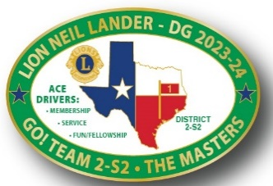 

**District 2-S2 2nd Cabinet Meeting**

October 21, 2023

1. Welcome
2. Prayer – SVDG Mike George
3. Pledges – PDG Chris Moorman
4. Quorum? – Secretary Minette
5. DG Comments and District Goals Review – Lion Neil
6. Financial Updates – Treasurer Ralph Perez
7. GAT-D Forward Thoughts – Plans
   1. GLT-D PDG Lisa Free-Martin (MD-2 Training)
   2. GET-D PDG Mark Roth
   3. GST-D Patti Dugan
   4. GMT-D Emee Nisnisan
   5. GMA-C FVDG Bill Simpson (FVDG Training)
8. Opportunities for Youth – PDG Rick and Lion Marla Reynolds
9. Peace Poster Contest – SVDG Mike George
10. LEO Tina Ly – Her LEO Experience
11. Seal Beach LC Video

Break – 15 Minutes

1. Proposed District 2-S2 Constitutional Revisions – PDG Chuck Martin
2. Zone Chairs – The MASTERS – Updates/Forword Planning Thoughts
   1. M-1 Kevin Smith
   2. A-1 Bill Hogan (Club Event)
   3. S-1 Suzie Vestal
   4. T-1 Dr. Anthony Price
   5. E-1 Valarie James
   6. R-1 John Tankersley
   7. S-2 Caral Barnett (Club Event)
3. Mid-Winter Conference/District Convention Planning – PDG Rick Reynolds
4. Bob Dowden Dinner – Lions Kari McMurray and Shelia Thomas
5. Mission 1.5 – District Membership Incentives – Lion Neil
6. New LCI Platform Update and District Communications – PDG Tony Austin
7. Other Reports? Resolutions?
8. Cabinet Roles – Training?